
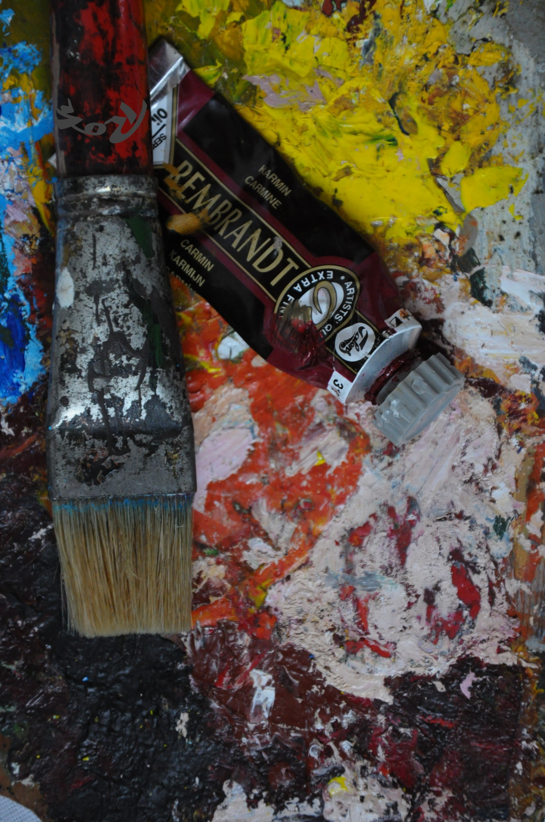
Foto Rok Čokl
ART COLONY IZLAKE -ZAGORJE | PROGRAM OF ACTIVITIES 2026

Program of Activities at the 63rd Izlake - Zagorje Painting Colony*

Friday, July 10, 2026

From 15.00 Arrival and reception of colony participants, accommodation in Guesthouse Kum
in Zagorje and getting acquainted with the surroundings and work spaces in Delavski
dom Zagorje – members of the Colony Council

18.00 Meeting with the members of the Colony Council, introduction of participants, and
overview of the colony programme schedule – all participants

20.00 Performance by the Trio Vivere at the square in the centre of Zagorje ob Savi –
individual participation

Saturday, July 11, 2026

Painting, socializing and conversing

19.00 Opening of the exhibition of works created during the 62nd Art Colony Sićevo (Serbia),
welcome of the visiting representatives, musical performance

Sunday, July 12, 2026

10.00 Hike to Čemšeniška planina with guide Milan Bedrač – individual participation

Painting, socializing and conversing

Monday, July 13, 2026

Painting, socializing and conversing

Tuesday, July 14, 2026

Painting, socializing and conversing

16.00 Guided tour of the city sights – departure in front of Guesthouse Kum – guided by
Kristina Renko

18.00 Opening of the photography exhibition – Photo Galery f 2.8 – Zagorje ob Savi

Wednesday, July 15, 2026

16.00 Guided tour of the Mining Museum Zagorje in Kisovec, followed by a drive to Trbovlje for a

tour of the Zasavje Museum and a visit to the Prometej Rudar statue on the nearby hill

Thursday, July 16, 2026

9.00 – 12.00 Children’s art colony – Let’s Play with Colours – DPM, Slavi Artnak and Barbara Lekše

15.00 Round trip excursion – viewing of the “Art Kum” art collection at Počakovo Castle, followed
by dinner at Guesthouse Čop

Friday, July 17, 2026

Painting, socializing and conversing

Saturday, July 18, 2026

15.00 - 19.00 Occasional exhibition of the created artworks in the Glass Hall of Delavski dom Zagorje

After completion, submission of finished artworks to Milan Razboršek for the regular

art exhibition in December in Zagorje ob Savi

19.00 Closing ceremony in the lobby of Delavski dom Zagorje – presentation of

participants, followed by a musical performance by Drago Mislej – Meh

20.30 Group dinner at Guesthouse Ribnik in Zagorje ob Savi

Sunday, July 19, 2026

Official end of the colony and goodbye

All departures are from Guesthouse Kum in Zagorje ob Savi!

We wish you a pleasant stay and successful work!

* The program is provisional and may be adjusted, especially in case of unfavorable weather conditions

